Improved Tripmaster
There are lots of @ riders who have mounted an additional digital speedometer on their bike, either just for fun or because they don't trust their analog speedometer.
There are several offers on the aftermarket, but I will tell you one which is definitely cheaper than any other one and looks even better. The solution is quite simple:
Use your tripmaster !
Although nowhere described the @'s tripmaster contains the option to show the cruising speed permanently on its display! Unfortunately this feature is disabled by default (law/technical limitations ?), but you can do the necessary work to enable it very easily on your own.

This is what you have to do:
• First of all remove all power connectors from the tripmaster, remove it from the bike and do the work at a calm and dry place.
• Now open the tripmaster with six screws on the backside. Then open it carefully to avoid destruction of the seal.
• You can see the backside of the mainboard. Loosen the main board to reach its frontside. This is done by removing five further screws.
• Now you should see the board as shown on the picture:
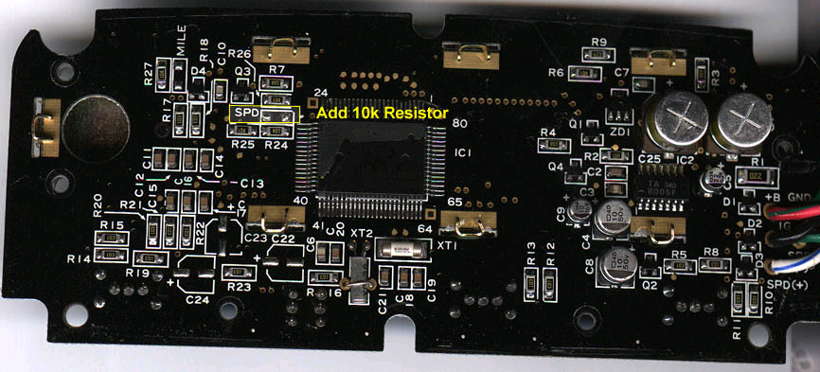
• On the left side of the big IC in the middle you'll find two open contacts, labeled with SPD (stands for SPeeD). Now you simply have to connect these both points with an resistor of about 10.000 Ohms. Solder it flat on the board to secure enough free space after closing the box.
(using a zero resistance works also, but with the 10k resistor you are sure not to overload any circuits)
• That's it. From now on you should be able to switch with the mode button between Trip1, Trip2, -Trip and Speed ! Additionally you can choose between mileage and kilometer distance display by inserting/removing an additional resistor at the point marked with MILE in the same way.
However, there is a small problem with this modification: If you press the "reset" switch while in speed mode, the tripmaster hangs. It needs a complete reset then, which can be done by pressing the clock adjustment (time and adjust at the same time) and everything returns to the normal condition. Additionally, the SPEED display doesn't switch to miles if you insert the resistor, which would have been an excellent option for bikes assembled with an km/h analog speedometer and imported to a mph country ... Perhaps this "techical lack" is the reason why the SPEED display is disabled by default.
Of course you do any modifications decribed above on your own risk !!!

